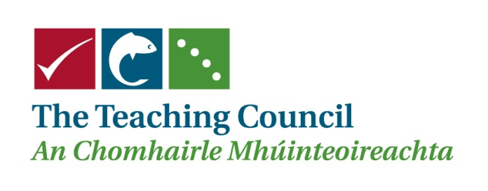

Career Entry Professional Programme (CEPP)

FEEDBACK FORM

Feedback to be emailed by close of business Friday 24 February 2012

To education@teachingcouncil.ie

SUBMITTED BY: NAME:
TITLE:
DATE:
ORGANISATION:
EMAIL ADDRESS:
PHONE NUMBER:

Please confirm if this submission is made in an individual capacity or on behalf of your organisation:
Individual Capacity ________ On behalf of organisation ________

General feedback

Include feedback here (Please use page numbers, section headings and section numbers, as appropriate)

Feedback by Section |  | Include feedback below (Please use page numbers, section headings and section numbers, as appropriate.)
- Introduction
- CEPP and the Continuum of Teacher Education
- Guiding Principles of CEPP
- The CEPP Programme
 | 4.1 The School-based Strand
 | 4.2 The Out-of-School Strand
 | 4.3 The Professional Development Portfolio
 | 4.4 The NQT’s CEPP Plan
 | 4.5 Standards for Full Registration
- Dealing with NQT’s concerns
- Settings where CEPP can take place
- The Timeframe for Completion of the CEPP programme
- Quality Assurance of the CEPP programme
- Transitional Arrangements: September 2012 to September 2016
- Ongoing Review of CEPP
- Appendix 1: Stakeholder Roles

Feedback by Section | Include feedback below (Please use page numbers, section headings and section numbers, as appropriate.)

Appendix 2: Key Phases of CEPP

Appendix 3: The Observation of Practice and the Provision of Feedback

Appendix 4: Duration of School-Based Strand

Appendix 5: Processing of Final Reports by the Teaching Council

Appendix 6: Relevant Provisions of the Teaching Council Act, 2001

Appendix 7: Interim Report Form

Appendix 8: Final Report Form

