PUPIL SUPPORT FILE
Class Support

Name of Pupil:

Date of Birth:

School:

Date File Opened:

Date File Closed:

A Continuum of Support

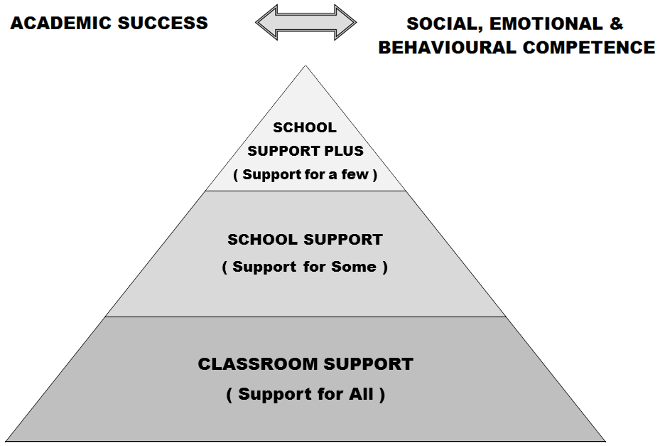

Developing a pupil support plan is the outcome of a problem solving process, involving school staff, parent(s)/ guardian(s) and the pupil. We start by identifying concerns, we gather information, we put together a plan and we review it

Pupil Support File, Log of Actions/Meetings

Date: Actions:

Support Checklist
Name: | Age: | Class:
General Information: | Date Checked: | Comments:
- Parents/ Guardians Consulted
- Information from previous school/preschool gathered
- Hearing
- Vision
- Medical Needs
- Basic Needs Checklist completed
- Assessment of learning- screening
- Observation of learning style/approach to learning
- Observation of behaviour
- Interview with pupil
- Classroom work differentiated?
- Learning environment adapted?
- Yard/school environments adapted?
- Informal or formal consultation/advice with outside professionals?
- Advice given by learning support/resource teacher or other school staff?
- Other interventions put in place in school?
Action Needed:
Helpful references: SEN: A Continuum of Support: Resource Pack for Teachers, pp. 13-16, 18 to 20; BESD: A Continuum of Support, p 7; A Continuum of Support for Post-Primary Schools, Resource Pack for Teachers, pp32-36; Pupil Support Teams in Post-Primary Schools, pp20

Basic Needs Checklist

Physiological needs e.g. does the child have adequate food, warmth, housing etc?

Safety needs e.g. does the child need physical or psychological protection?

Belonging needs e.g. does the pupil have close family and friends, feel part of his / her class.

Esteem needs: e.g. does the child receive respect, positive feedback from others and respect others and self?

Possible actions suggested to the teacher on the basis of the questions above:

CLASSROOM SUPPORT PLAN

Pupil’s Name: |  |  |  | Age in Sept:
Teacher: |  |  |  | Class/Year:
Start Date of Plan: |  |  | Review Date of Plan:
Pupil’s strengths and interests

Agreed Priority Concerns:
1.
2.
3.
4.
Priority Concerns were agreed between Parents and Teacher, taking cognisance of assessment results, the child’s strengths and challenges, recommendations from outside agencies (if any)
Targets for the Pupil:
Parents and class teacher have agreed to work on the following targets, based on the priority concerns. Parents and class teachers have been given a copy of the agreed priority concerns and targets.
1.
2.
3.
4.
Strategies to help the pupil achieve the targets – Detailed in Class Teacher Plans
Others involved:

Signature of Parent(s)/ Guardian(s):
Signature of Teacher:
Classroom Support Review Record: |  |  |  |  | Date:

