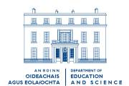

Circular Letter 14/02

Primary Branch

To Boards of Management and Principals of National Schools

Irish Primary Principals’ Network

The Minister for Education and Science, Dr. Michael Woods, T.D., recently granted recognition to the Irish Primary Principals’ Network as a professional body for Principals in primary schools. The organisation will be given representation on appropriate groups and committees under the aegis of the Department of Education and Science.

Following consideration of representations made to the Department, I am directed to inform you that the cost of membership subscriptions to the new Network is an appropriate charge on school funds. Accordingly, individual school management authorities may, if they wish, meet this cost from funding advanced by the Department towards the school’s operating costs.

Dermot Ryan
Principal Officer

April 2002

