Electricity

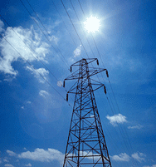

How to read your meter

There are 3 types of meters:
Single Tariff Meters
Double Tariff Meters
Electronic Meters

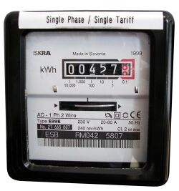

Single Tariff Meter
This is the most common type of meter. It shows your entire electricity consumption on one dial.
To read a Single tariff Meter, simply follow these steps:
Step 1: Record the Meter Number. This is an eight digit number pre-fixed with the letter "No." (e.g. "No. 23 456 789")
Step 2: Read and record the numbers on the dial from left to right.
Note: Include any zeros at the start of the reading and do not include any numbers in red or in a red box.
The meter reading for the above Single Tariff Meter is 00457.

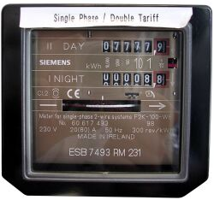

Double Tariff Meter

If you are a Night Saver customer, you may have a Double Tariff Meter. This meter has two dials, one for daytime consumption and one for night-time consumption. Therefore, there are two separate readings required; one daytime reading and one night time reading.
To read a Double Tariff Meter, simply follow these steps:
Step 1: Record the Meter Number. This is an eight digit number pre-fixed with the letter "No." (e.g. "No. 23 456 789")
Step 2: Read and record the numbers from the "day dial" from left to right.
Step 3: Read and record the numbers from the "night dial" from left to right.
Note: Include any zeros at the start of the reading and do not include any numbers in red or in a red box.
The meter readings for the above double tariff meter are:
Daytime: 07777
Night-time: 00008

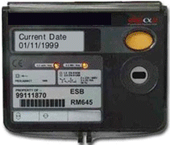

Electronic Meters

These types of meters have scrolling electronic displays which display a number of different meter readings.
Take your reading from the appropriate screen depending on your price plan
Note numbers from left to right
Ignore any figures to the right of the decimal place

The display automatically changes every 9 seconds to show you 20 different types of meter readings. Maximum Demand customers should take readings from:
Screen 14: Normal
Screen 16: Peak
Screen 18: Day
Screen 19: Night
Screen 20: Wattless

All other customers should take readings from:
Screen 9: Normal (or Day)
Screen 10: Night
Screen 11: Wattless

Natural Gas

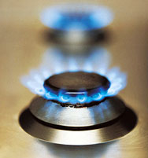

How to read your meter

Non-Volume corrected

all meters where annual usage at the site is < 3,000,000 kWh

Volume Corrected

all meters where annual usage at the site is GREATER than 3,000,000 kWh

Digital Meter:
If your meter has direct reading digits, like the diagram below, read the figures as they are shown.
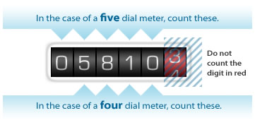
The reading on this meter is 5810. The digits in the red area are not included in the meter reading.

Dial Clock Meter:
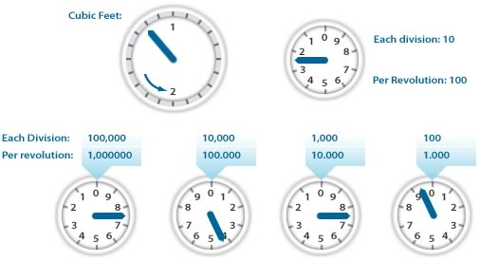
The reading on this meter is 7479.
If your meter displays a series of dials (clocks), like the diagram above, you should ignore the top two dials and use the four small dials at the bottom to read your meter.
When giving your meter reading you should read the dial on the left first and move along to the right.
The position of the pointer on the dial indicates the meter reading.
If the pointer is between two figures, use the lower figure, e.g. if it is between 7 and 8, use 7. However, if the pointer is between 9 and 0, use 9.
