PUPIL SUPPORT FILE
Moving from Class Support to School Support

Name of Pupil:

Date of Birth:

School:

Date File Opened:

Date File Closed:

A Continuum of Support

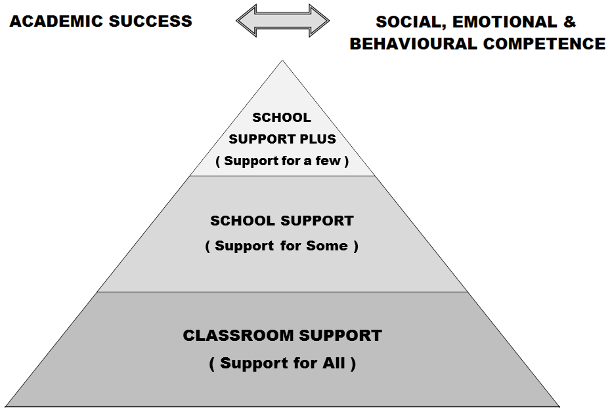

Developing a pupil support plan is the outcome of a problem solving process, involving school staff, parent(s)/ guardian(s) and the pupil. We start by identifying concerns, we gather information, we put together a plan and we review it.
ASSESSMENT RECORD
Junior Infants | Senior Infants | First Class
PSAK Initial Assessment  _____________ | PSAK Initial Assessment  _____________ | PSAK Initial Assessment  _____________
PSAK Level 1 Assessment  _____________ | PSAK Level 1 Assessment  _____________ | PSAK Level 1 Assessment  _____________
Letter Sounds  ______ / 26 | DTEN  Pre-Number ______% | Micra T  STEN __________  %ile ___________
Letter Formation  ______ / 26 | DTEN  Numeration ______% | Sigma T  STEN __________  % ile ___________
BIC Language Skills  ______ / 20 | DTEN  Addition & Subtraction  ______% | BAS  Reading Age  _______ Y _______M
BIC Memory Skills  ______ / 12 | DTEN - Total (Cut-Off 17)  _______
BIC Number Skills  ______ / 9 | MIST - Listening Skills  ________ / 15
BIC Motor Skills  ______ / 11 | MIST - Letter Sounds  ________ / 26
BIC Total  ______ / 60 | MIST - Written Vocabulary  ________
MIST - 3 Phoneme Words
________ / 15
MIST - Dictation
________ / 36
BAS - Reading Age
_______ Y _______M

Outside Professionals / Agencies
Agency (SLT, OT etc) | Name of Professional | Date of Report | Diagnosis
SUPPORT PLAN
Classroom Support
School Support (Support for Some)
School Support Plus (Support for A Few)

Pupil’s Name: |  |  |  | Age in Sept:
Teachers: | Class Teacher:  LSRT(s): |  |  | Class/Year:
Start Date of Plan: |  |  | Review Date of Plan:
Pupil’s Strengths and Interests:

Agreed Priority Concerns:
1.
2.
3.
4.
Priority Concerns and were agreed between Parents and Teachers, taking cognisance of assessment results, the child’s strengths and challenges, recommendations from outside agencies (if any)
Targets for the Pupil:
Parents, class teachers and support teachers have agreed to work on the following targets, based on the priority concerns. Parents and class teachers have been given a copy of the agreed priority concerns and targets.
1.
2.
3.
4.
Strategies to help the pupil achieve the targets – Detailed in Class Teacher and LSRT Plans
Others Involved:

Signature of Parent(s)/ Guardian(s):
Signature of Teacher:

SUPPORT REVIEW RECORD Classroom Support
School Support (Support for Some)
School Support Plus (Support for A Few)
To be completed as a review of the plan and as a guide for future actions
Refer to the ASSESSMENT TABLE for Assessment Results
Pupil’s Name: |  |  |  |  | Class/ Year:
Names of those present at review: |  |  |  |  | Date of Review:
Child’s progress to date in relation to targets:

Have the pupil’s needs changed since the start of the plan, and if so how?

Feedback from Parents:

Feedback from Class Teachers:

Signature of Parent(s)/Guardian(s):
Signature of Teacher(s):
Outcome of Review (tick as appropriate):
 | Revert to previous level of support- Support for All/ Classroom Support OR Support for Some/ School Support |  |  | Progress to next level of support- Support for Some/ School Support OR Support for a Few/ School Support Plus
 | Continue at Current Level of Support |  |  | Request consultation with other professionals

